
COURSE NAME
Data Structure and Algorithm
Assignment No: 09
Submitted To: Ma’am Yusra Tahir
Submitted By: Princess Spogmai Jan
2430-0081
Submission Date: 12/09/2025
DEPARTMENT OF Computer Science
SIR SYED CASE INSTITUTE OF TECHNOLOGY, ISLAMABAD

Task No: 01
Code:
#include<iostream>
using namespace std;
void read(int* arr, int n)
{
for (int i = 0; i < n; i++)
{
arr[i]=2*(i+1);
}
}
void display(int* arr, int n)
{
for (int i = 0; i < n; i++)
{
cout << arr[i] << " ";
}
}
void Replace(int* arr, int n)
{
for (int i = 0; i < n; i++)
{
if (arr[i] % 4 == 0)
{
arr[i] = i;
}
}
}
int main()
{
int arr[10];
read(arr, 10);
display(arr, 10);
Replace(arr, 10);
cout << endl;
display(arr, 10);
}

Function to initialize the array: each element is set to 2 * (i + 1).

Loop runs from 0 to the size of the array (10).

Function to display the array elements.

Prints each element followed by a space.

Function to replace array elements divisible by 4 with their index.

Checks each element, and if divisible by 4, replaces it with the index.

Declare an array of size 10.

Call read() to initialize the array.

Call display() to print the array.

Call replace() to modify elements divisible by 4.

Call display() again to show the updated array.

Output:
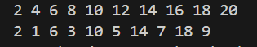

Task No: 02
Code:
#include <iostream>
using namespace std;

class Stack {
private:
int data[100];
int topIndex;
int maxSize;

public:
Stack(int size) {
maxSize = size;
topIndex = -1;
}

void push(int value) {
if (topIndex == maxSize - 1) {
cout << "Stack is full!\n";
return;
}
topIndex++;
data[topIndex] = value;
cout << value << " added to stack.\n";
}

int pop() {
if (topIndex == -1) {
cout << "Stack is empty!\n";
return -1;
}
int removed = data[topIndex];
topIndex--;
return removed;
}

void display() {
if (topIndex == -1) {
cout << "Stack is empty!\n";
return;
}
for (int i = topIndex; i >= 0; i--) {
cout << data[i] << " ";
}
cout << endl;
}
};

int main() {
Stack s(5);
s.push(10);
s.push(20);
s.push(30);

s.display();

cout << "Popped: " << s.pop() << endl;
s.display();

s.push(40);
s.display();

return 0;
}

Output:
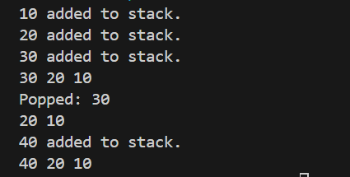

Task No: 03
Code:
#include <iostream>
#include <vector>
using namespace std;

class Stack {
private:
vector<int> arr;
int capacity;

public:
Stack(int size) {
capacity = size;
}

void push(int x) {
if (arr.size() == capacity) {
cout << "Stack is full!\n";
return;
}
arr.push_back(x);
cout << x << " pushed into stack.\n";
}

int pop() {
if (arr.empty()) {
cout << "Stack is empty!\n";
return -1;
}
int value = arr.back();
arr.pop_back();
return value;
}

void display() {
if (arr.empty()) {
cout << "Stack is empty!\n";
return;
}
for (int i = arr.size() - 1; i >= 0; i--) {
cout << arr[i] << " ";
}
cout << endl;
}
};

int main() {
Stack s(5);

s.push(10);
s.push(20);
s.push(30);

s.display();

cout << "Popped: " << s.pop() << endl;
s.display();

s.push(40);
s.push(50);
s.display();

cout << "Popped: " << s.pop() << endl;
s.display();

return 0;
}

Output:
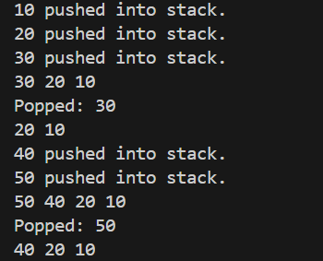

Task No 04:
Code:
#include <iostream>
using namespace std;

class Stack {
private:
int arr[64];
int top;
public:
Stack() {
top = -1;
}

void push(int x) {
arr[++top] = x;
}

int pop() {
return arr[top--];
}

bool isEmpty() {
return top == -1;
}
};

int main() {
int n;
Stack s;

cout << "Enter an integer: ";
cin >> n;

if (n == 0) {
cout << "Binary: 0\n";
return 0;
}

bool negative = false;
if (n < 0) {
negative = true;
n = -n;
}

while (n > 0) {
s.push(n % 2);
n /= 2;
}

if (negative) cout << "Binary: -";
else cout << "Binary: ";

while (!s.isEmpty()) {
cout << s.pop();
}
cout << '\n';

return 0;
}

Output:
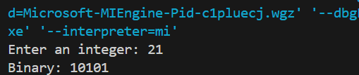

Task No: 05
Code:
#include <iostream>
using namespace std;

class Node {
public:
int data;
Node* next;
Node(int value) {
data = value;
next = NULL;
}
};

class Stack {
private:
Node* top;

public:
Stack() {
top = NULL;
}

void push(int x) {
Node* newNode = new Node(x);
newNode->next = top;
top = newNode;
cout << x << " pushed into stack.\n";
}

int pop() {
if (top == NULL) {
cout << "Stack is empty!\n";
return -1;
}
int value = top->data;
Node* temp = top;
top = top->next;
delete temp;
return value;
}

void display() {
if (top == NULL) {
cout << "Stack is empty!\n";
return;
}
cout << "Stack elements (Top to Bottom): ";
Node* temp = top;
while (temp != NULL) {
cout << temp->data << " ";
temp = temp->next;
}
cout << endl;
}
};

int main() {
Stack s;

s.push(10);
s.push(20);
s.push(30);

s.display();

cout << "Popped: " << s.pop() << endl;
s.display();

s.push(40);
s.display();

return 0;
}

Output:
